DECLARE

v_myage NUMBER;

BEGIN

IF v_myage < 11

THEN

DBMS_OUTPUT.PUT_LINE('I am a child');

ELSE

DBMS_OUTPUT.PUT_LINE('I am not a child');

END IF;

END;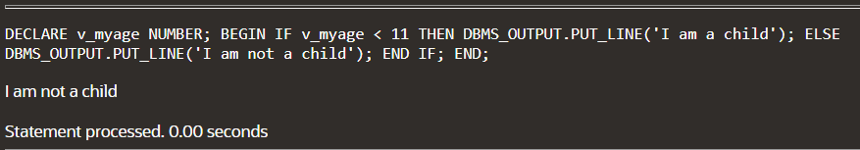

CREATE TABLE PERSON2(FIRST_NAME Varchar(20),LAST_NAME Varchar(20),AGE Number,DOB Number,BLOOD_GROUP Varchar(20),DEPARTMENT_NAME Varchar(30),DEPARTMENT_ID Number,SALARY Number,DOY Number,ADDRESS Varchar(30),FATHER_NAME Varchar(30),MOTHER_NAME Varchar(30));

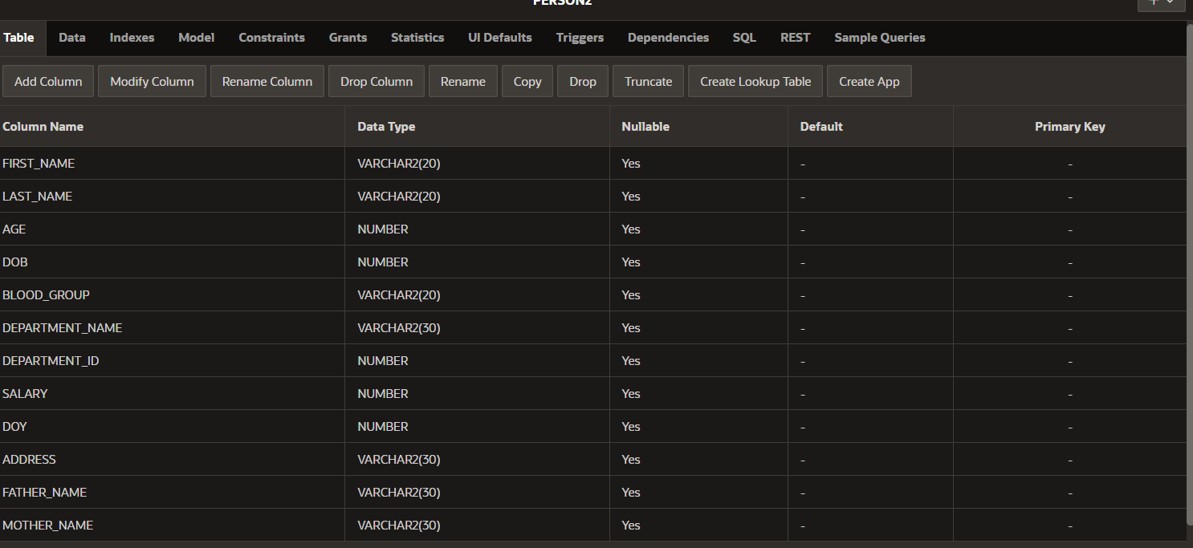

INSERT INTO PERSON2 VALUES('CHALLA','PRIYADARSHINI',19,04-07-2006,'O POSITIVE','CSE',1234,100000,2006,'KHAMMAM','SEETHARAMULU','SEETHA');

INSERT INTO PERSON2 VALUES('CHALLA','NEHACHATURYA',12,28-10-2010,'A POSITIVE','MEDICAL',1345,150000,2010,'KHAMMAM','SEETHARAMULU','SEETHA');

INSERT INTO PERSON2 VALUES('NERSU','HARIKA',20,14-1-2005,'B POSITIVE','BIO',1876,151230,2005,'KOTHAGUDEM','NAGESHWARROA','PADMA');

INSERT INTO PERSON2 VALUES('SAMINENI','YASHASWINI',18,20-11-2004,'O POSITIVE','AI',1678,160000,2004,'KANAPUR','VENKATESH','BABY');

INSERT INTO PERSON2 VALUES('KARNATI','KAVYANJALI',8,22-10-2009,'AB POSITIVE','PHARMACY',1346,200000,2009,'ANDHRA','SRIRAM','RADHA');

INSERT INTO PERSON2 VALUES('PAVULURI','NIKHITHA',21,29-12-2024,'A POSITIVE','DS',1349,150054,2024,'KHAMMAM','MALLIKARJUNA','LATHA');

INSERT INTO PERSON2 VALUES('CHALLA','SEETHARMULU',49,04-02-1987,'A POSITIVE','FARMER',1923,500000,1987,'KHAMMAM','VEERAIAH','VENKAMMA');

INSERT INTO PERSON2 VALUES('CHALLA','SEETHA',35,04-05-1993,'O POSITIVE','DELAR',1927,300000,1993,'KHAMMAM','GURAVAIAH','SEETHAMMA');

INSERT INTO PERSON2 VALUES('NERSU','JAYASREE',15,29-12-2008,'A POSITIVE','EEE',3455,150024,2008,'KOTHAGIDEM','NAGGI','RAMANA');

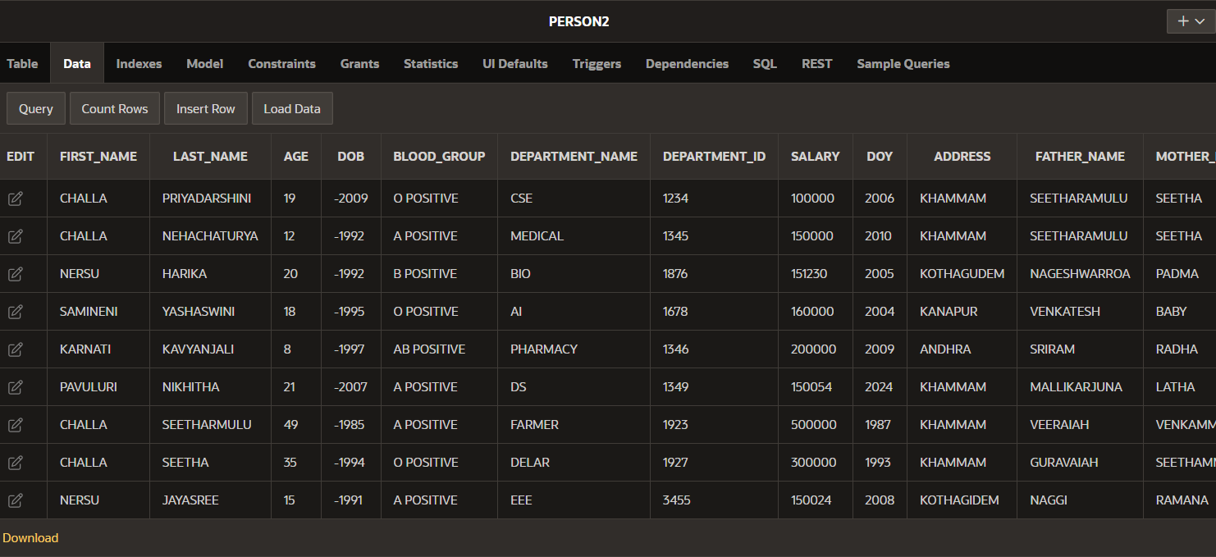

DECLARE

CURSOR my_cursor IS

SELECT FIRST_NAME,LAST_NAME,AGE,FATHER_NAME,MOTHER_NAME

FROM PERSON2

ORDER BY AGE ASC;

my_record my_cursor%ROWTYPE;

BEGIN

OPEN my_cursor;

LOOP

FETCH my_cursor INTO my_record;

EXIT WHEN my_cursor%NOTFOUND;

DBMS_OUTPUT.PUT_LINE(my_record.FIRST_NAME|| ' ' ||my_record.LAST_NAME|| ' ' ||my_record.AGE|| ' ' ||my_record.FATHER_NAME|| ' ' || my_record.MOTHER_NAME);

END LOOP;

CLOSE my_cursor;

END;

**OUTPUT:**

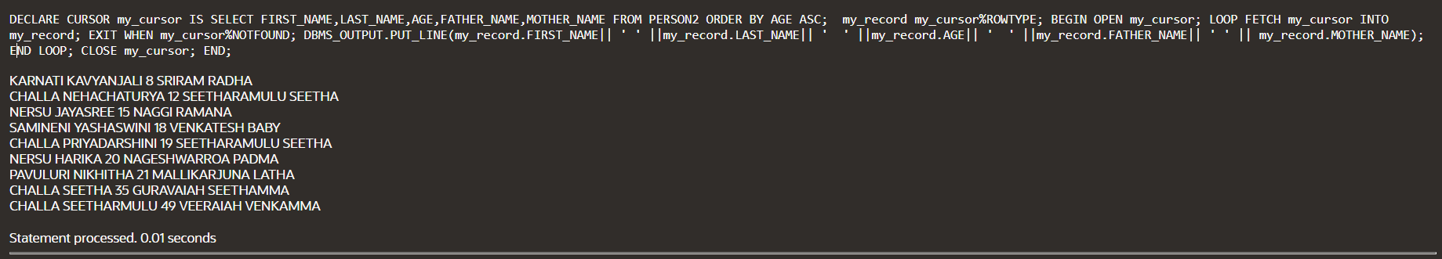

**GOTO STATEMENT:**

DECLARE

a number(2) := 35;

BEGIN

<<loopstart>>

WHILE a < 50 LOOP

dbms_output.put_line ('value of a: ' || a);

a := a + 1;

IF a = 40 THEN

a := a + 1;

GOTO loopstart;

END IF;

END LOOP;

END;

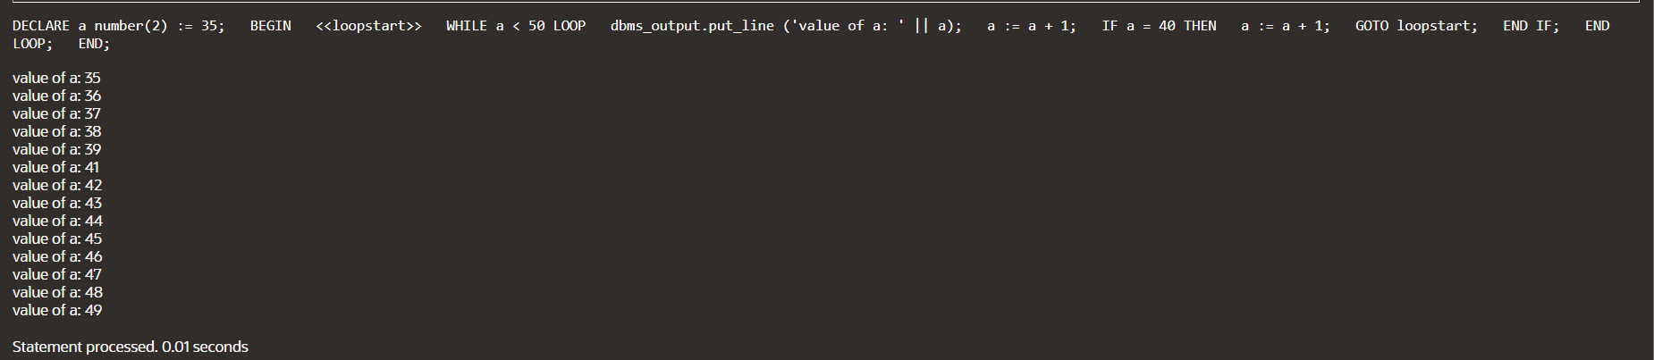

**DIVISION BY ZERO:**

DECLARE

dividend NUMBER := 10;

divisor NUMBER := 0;

result NUMBER;

BEGIN

result := dividend / divisor;

DBMS_OUTPUT.PUT_LINE('Result: ' || result);

EXCEPTION

WHEN ZERO_DIVIDE THEN

DBMS_OUTPUT.PUT_LINE('Error: Division by zero');

END;



**NO DATA FOUND:**

DECLARE

emp_name VARCHAR2(100);

emp_id NUMBER := 225;

BEGIN

BEGIN

SELECT EMPLOYEE_NAME INTO emp_name FROM EMPLOYEE WHERE DEPARTMENT_ID = emp_id;

DBMS_OUTPUT.PUT_LINE('Employee Name: ' || emp_name);

EXCEPTION

WHEN NO_DATA_FOUND THEN

DBMS_OUTPUT.PUT_LINE('Error: No matching record found');

END;

END;



**Handle the INVALID_NUMBER exception when converting a non-numeric value to a number.**

DECLARE

v_input VARCHAR2(10) := 'abc';

v_number NUMBER;

BEGIN

BEGIN

v_number := TO_NUMBER(v_input);

DBMS_OUTPUT.PUT_LINE('Conversion successful. Number: ' || v_number);

EXCEPTION

WHEN INVALID_NUMBER THEN

DBMS_OUTPUT.PUT_LINE('Error: Invalid number');

END;

EXCEPTION

WHEN OTHERS THEN

DBMS_OUTPUT.PUT_LINE('Error: ' || SQLERRM);

END;



**Handle the DUP_VAL_ON_INDEX exception when inserting a duplicate value into a table with a unique constraint.**

DECLARE

v_duplicate_value NUMBER := 125;

BEGIN

INSERT INTO PERSON2 (DEPARTMENT_id) VALUES (v_duplicate_value);

DBMS_OUTPUT.PUT_LINE('Insertion successful.');

EXCEPTION

WHEN DUP_VAL_ON_INDEX THEN

DBMS_OUTPUT.PUT_LINE('Error: Duplicate value already exists.');

END;

